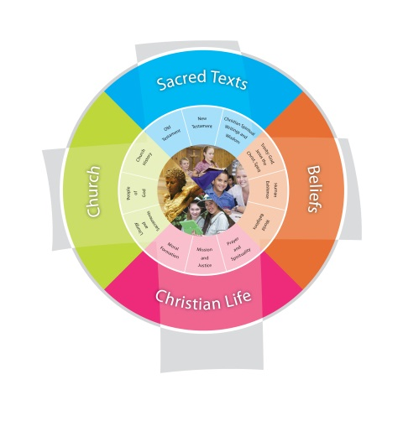
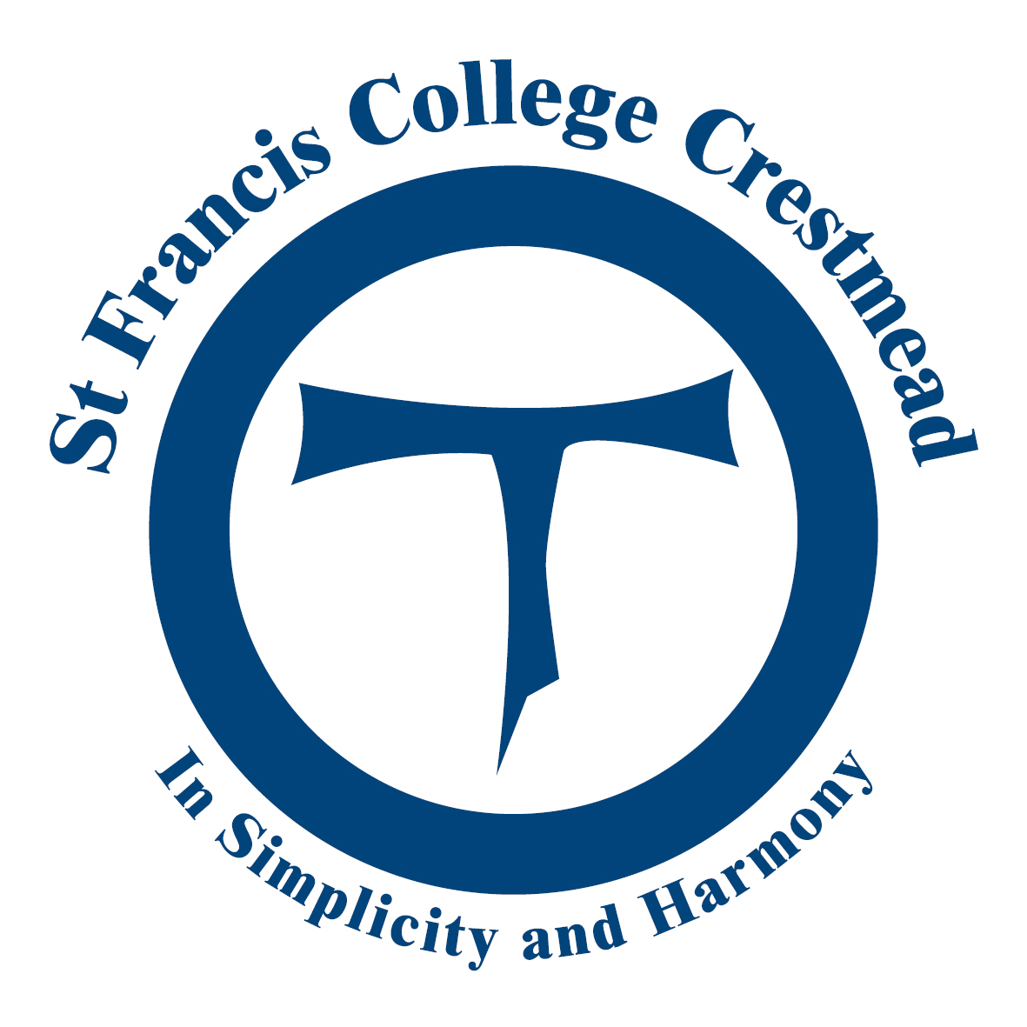 Year: Unit:
Religious Education
Term: 2015 Duration: Weeks
VISION: St Francis College aspires to educate and form students who are challenged to live the gospel of Jesus Christ and who are literate in the Catholic and broader Christian tradition so that they might participate critically and authentically in faith contexts and wider society.
Together we value individuals, build relationships and empower learning.
Fertile Question to guide the Inquiry
Class Context– Who are my learners?
- Class Needs
- Individualised Learning Needs/EALD contact Julie-Anne or Arti
- Catholics/non-Catholics – other faiths – practising/non-practising (Nicole Carter can provide this data for your class).
- Students with Disabilities [e.g. ASD – ADHD -abstract concepts may need further unpacking – visuals etc…] Contact Sandy

Learning Context - Significant Days and Celebrations
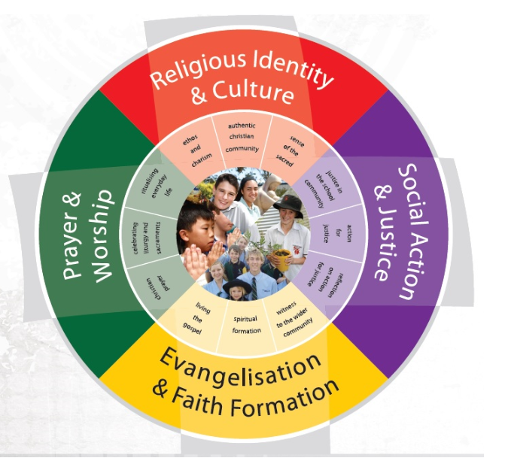
- What events/demands/celebrations are timetabled in the school for the duration of the unit?
- Religious Life of the School: Liturgies; Assembly Prayer; Feast days; Retreat Days; Social Justice Outreach etc
- Check Ways to Pray Calendar for significant dates in Liturgical Calendar
- Plan to integrate these things into learning, not add on top.

Year Level Description (Highlight the relevant parts of the Description that the unit will cover)
The Religion Curriculum P-12 involves four strands: Sacred Texts, Beliefs, Church and Christian Life. These strands are interrelated and are taught in an integrated way, and in ways that are appropriate to specific local contexts.

Achievement Standard (Highlight the relevant parts of the Standard that the unit will cover)
By the end of

Content Descriptions from BCE Religious Education Curriculum
Cluster strands and sub-strands that make connections with the Unit topic.
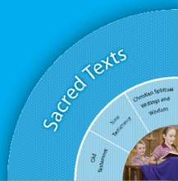
Sacred Texts: Old Testament * New Testament* Christian Spiritual Writings and Wisdom

Religious Knowledge and Deep Understanding | Skills
OLD TESTAMENT

NEW TESTAMENT
CHRISTIAN SPIRITUAL WRITINGS AND WISDOM

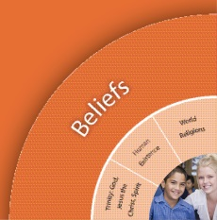
Beliefs: Trinity * Human Existence * World Religions

Religious Knowledge and Deep Understanding | Skills
TRINITY

HUMAN EXISTENCE

WORLD RELIGIONS
.
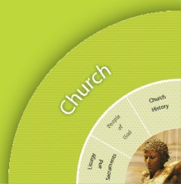
Church : Liturgy and Sacraments * People of God * Church History

Religious Knowledge and Deep Understanding | Skills
LITURGY AND SACRAMENTS

PEOPLE OF GOD

CHURCH HISTORY

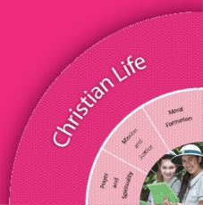
Christian Living: Moral Formation * Mission and Justice * Prayer and Spirituality

Religious Knowledge and Deep Understanding | Skills
MORAL FORMATION

MISSION AND JUSTICE

PRAYER AND SPIRITULAITY

Learning Intentions to be shared with students (Use Year Level Description to help focus these)
Learning Intentions
By the end these learning experiences, students

Success Criteria to be shared with students (Use achievement standard to help focus these) | Assessment to demonstrate success criteria
Success Criteria  How will we know if students have achieved the desired results and met the standard?  What will we accept as evidence of student knowledge, understanding and skills? | Assessment Background  Consider a range of assessment methods – informal and formal assessments during a unit  Ideas for adjustments

Mandated Scriptural Texts  Appendix B | EXPLICIT TEACHING ABOUT PRAYER  Appendix A

CURRICULUM Connections
What connections can be made with other Curriculum areas (eg History, Geography, English)? http://www.australiancurriculum.edu.au/Curriculum/Overview
Religious Life of the School  Focus for this unit | General Capabilities  Focus for this unit | Cross-Curricular Priorities  Focus for this unit
Religious Identity and Culture  - Ethos and charism (ICE)  - Authentic Christian community (ICC)  - Sense of the Sacred (ICS)  Social Action and Justice  - Justice in the school community (SJS)  - Action for justice (SJA)  - Reflection on action for Justice (SJR)  Evangelisation and Faith Formation  - Living the Gospel (EFG)  - Spiritual Formation (EFF)  - Witness to the wider community (EFW)  Prayer and Worship  - Christian prayer (PWP)  - Celebration of liturgy and sacraments (PWL)  - Ritualising everyday life (PWR) | - Literacy  - Numeracy  - Information and communication technology (ICT) capability  - Critical and creative thinking  - Personal and social capability  - Ethical understanding  - Intercultural understanding. | - Aboriginal and Torres Strait Islander histories, cultures and spiritualties  - Asia and Australia’s engagement with Asia in a multi-faith context  - Sustainability and ecological stewardship.
 |  | CCEs explicitly to be taught in this unit
Recommended Resources
Resources  Teacher Background  Mandated Scriptural Texts  A-Z Learning Strategies  Prayer Chart  Learning Bytes  Melbourne RESource, | Together at One Altar;  ResourceLink  Caritas  Judaism  Ways to Pray

CORE CONTENT AREA 1:
Learning Experiences - Select a relevant Inquiry Process

Explore Elaborations

Tuning In  - What is the topic?  - Why should we study this topic?  - Frame manageable questions.  - What do I already know about this topic? I think I know  - How is this relevant to me? |  | Finding Out  - Identify possible sources of information  - Identify skills necessary for the investigation.  - How did it happen?  - Who was there and what were the facts? | Sorting Out  What do we want to find out?  - How can we do this best?  - How will we gather the information?  - Does what I knew before still apply?  - Does my first idea still make sense? | Communicating  Extend and challenge students’ understandings  - Offer more information  - Is there something else I need to deepen my knowledge understandings?  - What difference does this make to me? |  | Reflecting and Evaluating  - So what have I learnt?  - If I know this, how can I connect it with my world?
Teaching and Learning Sequence  Focus/Question– |  |  |  |  | Resources  Adjustments for Learners

