Religious Education in Year Two for Parents
Term 1 | Term 2 | Term 3 | Term 4
Peaceful relationships  Students learn about hurtful and peaceful actions and the impact they have on others. They create a class covenant.  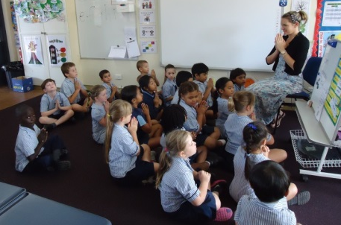  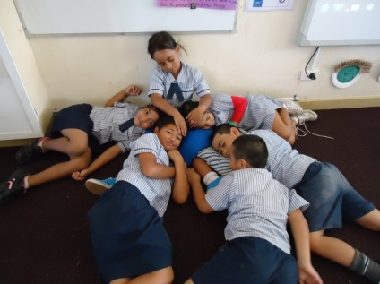 | History of the Church/Parish & Maximilian Kolbe  Students examine the history of Maximillian Kolbe Church and explore the life of St Maximillian Kolbe and the relationship with our school. They practice mindfulness using centred breathing with attention to posture.  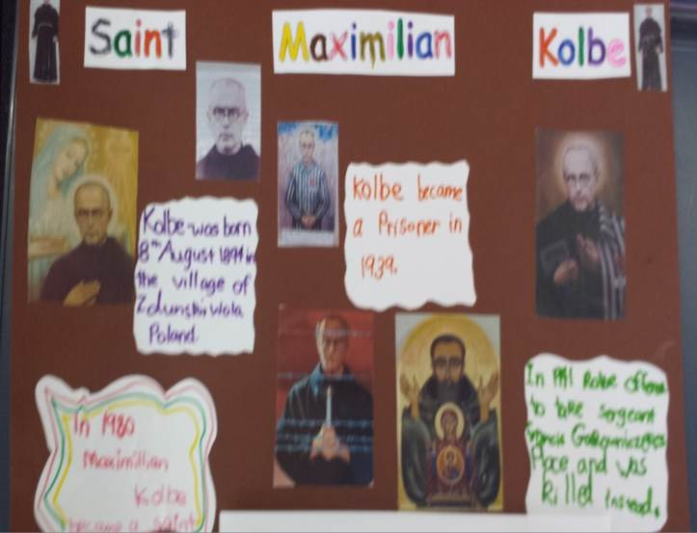 | Saying sorry and forgiving others  The students investigate the steps of seeking forgiveness and relate this knowledge to the sacrament of Reconciliation.  Students write sorry prayers.  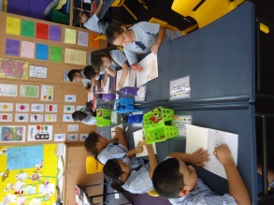  Students walk to the Parish church for Peace and Max. Kolbe’s Feast day | Stories of Jesus and meaning for our community today  Students explore the life and times of Jesus, investigate stories from the New Testament and make connections to the church community today.  