Religious Education in Year One - for Parents
Term 1  Who is God? Jesus’ Life and Mine | Term 2  God wants us to help others | Term 3  Care of Creation | Term 4  The life and Times of Jesus
Students discuss peace, justice, dignity and a responsibility to care before creating a class covenant.  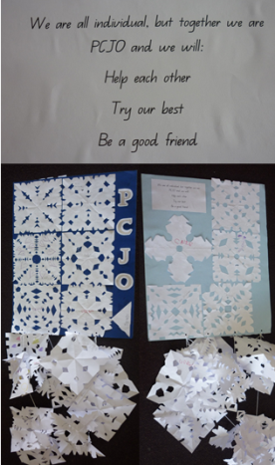  Students explore the question “Who is God?”. They create a class poster of words that describe God and then think of a way in which they could be like God eg: God is kind. I can be kind by . . . .  They sequence the main events of Jesus’ life in a timeline and their own life thus far.  Students engagein the celebration of Lent. They make pancakes to eat and write promises on paper pancakes. After break times, students discuss good deeds seen and done and these are recorded as petals on flowers on the board for all of Lent.  Students visitthe local Parish Church for Mass and learn about the different roles in the parish community. Students engage in meditative prayer, Grace, the Prayer of St Francis, prayers of gratitude and Echo prayers. | Students discuss the celebrations of Easter and the Stations of the Cross. They learn about Baptism, Eucharist and Pentecost. Students identify symbols used in the Sacraments.  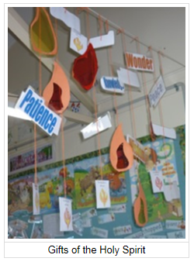  Students explore the Month of Mary, learning about the Mother of Jesus, praying with beads and saying the Hail Mary. Students were able to identify ways believers honour Mary  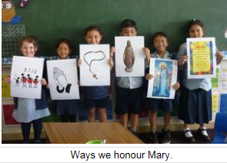  Students engaged in meditative prayer, Grace, the Prayer of St Francis, prayers of gratitude and Echo prayers. | Students discuss the responsibility they have to care for God’s creation and how they could live according to God’s plan. They explore the story of Noah in great depth. This is linked to Science and caring for animals and the environment as well as Geography and natural, managed and constructed environments. Students are able to identify things God created and how they have and will continue to live to God’s plan.  Noahs Ark Display  Students participate in the Peace March to the local Parish Church for Mass. Students engage in meditative prayer, Grace, the Prayer of St Francis, prayers of gratitude and Echo prayers.  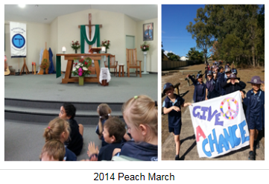 | Students focus on Jesus’ mission and compare the similarities and differences between Gospel accounts of Jesus’ life. They explore what life was like at the time of Jesus. They describe what meals, prayer and leisure was like and whether it was easy or hard in the time of Jesus. Students learn how God was present in the lives of Moses, Esther and Ruth and brainstorm how God is present in their lives. They also learn about the true meaning of Christmas and the birth of Jesus. Students engage in meditative prayer, Grace, the Prayer of St Francis, prayers of gratitude and Echo prayers.

