Religious Education in the Year 8 class for Parents
Term One | Term Two | Term Three | Term Four
Mission Matters  Fertile Question: Jesus’ mission today…mission possible?  Students explore What is mission? And how  believers and communities  continue Jesus’ mission in the world today | Movers and shakers  Fertile Question: How does faith inspire action?  Students investigate the reformers in a time of great challenge and change. They complete and Inquiry investigation in to heroes and role models of one of the major times of change, renaissance, reformation, etc.  They participate in contemplative prayer including centred breathing with attention to posture. | Unity and diversity  Fertile Question: How are new members welcomed into their community?  Students investigate birth and initiation rituals, in Christianity, Judaism and Islam. They explore the text of the Acts of the  Apostles about discipleship in the early Christian church. Learn about and participate in the prayer of the Church and prepare for and participate in a class Mass.  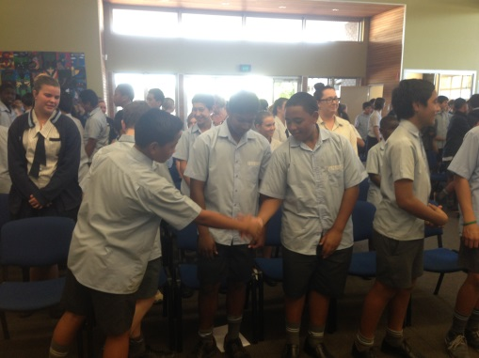 | Covenant  Fertile Question: Why should we do what we say we’ll do?  Students investigate the concepts of Covenant and God’s covenant  with God’s people.

