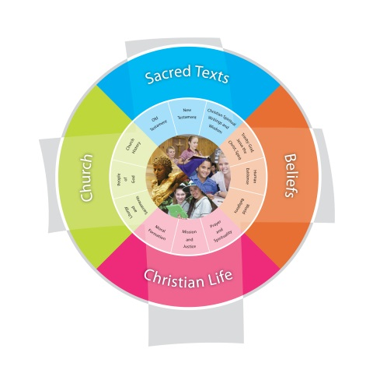
Term Three Year: Prep 2014
School: St Francis College - Crestmead Duration: 4 weeks
Unit: And Jesus…
How do I be a Good Samaritan today?
….walking in the footsteps of Jesus….
VISION for Religious Education
The Vision for Religious Education gives voice to what each school hopes for their students in terms of their religious literacy and faith formation. The schools and colleges of the Archdiocese of Brisbane aspire to educate and form students who are challenged to live the gospel of Jesus Christ and who are literate in the Catholic and broader Christian tradition so that they might participate critically and authentically in faith contexts and wider society.

Religious Life of the School | General Capabilities | Cross-Curricular Priorities
Evangelisation and Faith Formation  - Living the Gospel (EFG)  Celebrating the Good News EFG3  ​Identifying and using scripture texts to promote and support the Christian values of the school EFG3.1 | Literacy  listening to, reading, viewing, speaking, writing and creating oral, print, visual and digital texts, and using and modifying language for different purposes in a range of contexts.  Numeracy  Information and communication technology (ICT) capability  learn to use ICT effectively and appropriately to access  Critical and creative thinking  Generating ideas, possibilities and actions  Imagine possibilities and connect ideas  use imagination to view or create things in new ways and connect two things that seem different  Personal and social capability  understand themselves and others, and manage their relationships  Ethical understanding  to develop an awareness of the influence that their values and behaviour have on others.  Intercultural understanding.  Intercultural understanding is an essential part of living with others in the diverse world of the twenty-first century | - Aboriginal and Torres Strait Islander histories, cultures and spiritualities  - Asia and Australia’s engagement with Asia in a multi-faith context  - Sustainability and ecological stewardship.
Year Level Description

Prep Year Level Description

In Prep, students learn about some Old Testament and New Testament stories that tell of a God of love, the creator of all, the goodness of God’s creation, God’s special relationship with all of creation and God’s plan that people help each other to live safely and happily together, for the good of all.
Students listen to, read and view stories of and about Jesus in the Gospels that tell of Jesus’ life as a Jew, his mother Mary, his friends and family; of Jesus praying and teaching others to pray; of his teachings about love, compassion and forgiveness that challenged people about the way they were living; and of his suffering, death and resurrection. They learn that Christians believe God created people with the freedom to choose between good and bad, right and wrong. They explore examples of times, from familiar texts and their personal experience, when people make these choices.
Students understand that prayer helps believers follow the teachings of Jesus; to live according to God’s plan. They learn about ways in which believers pray, either alone or with others, including the Sign of the Cross and Amen. They observe ways in which believers pray together during special celebrations and rituals that mark important times in the life of believers and in the Church year. They learn about the Church building as a sacred place for believers and the Bible as a sacred book for believers.

Achievement Standard
By the end of Prep, students communicate clearly their ideas, feelings and thoughts about God, the goodness of God’s creation and God’s plan that people help each other to live safely and happily together, for the good of all. They identify connections between some Old Testament stories and their personal experience, including the experience of the goodness of creation. They listen and respond to stories of and about Jesus in the Gospels that tell of Jesus’ life as a Jew, his mother Mary, his friends and family; of Jesus praying and teaching others to pray; and of his suffering, death and resurrection. They recognise Jesus’ teachings about love, compassion and forgiveness that challenged people about the way they were living. They relate examples of people having the freedom to choose between good and bad, right and wrong.
Students understand that prayer helps believers to follow the teachings of Jesus; to live according to God’s plan. They recognise ways in which believers pray either alone or with others, using word, music, action, silence, images, symbols and nature, and participate with respect in a variety of these prayer experiences, including meditative prayer, the Sign of the Cross, and Amen. They describe ways in which believers pray together during special celebrations and rituals that mark important times in the life of believers and in the Church year.

Class Context for Learning – Differentiated learning
Class Needs: big book of the story; Puppets; Screen to view animated version; costumes to re enact

Individualised Learning Needs : SO to read and review story with some children on an individual basis multiple times

Catholics/non-Catholics – other faiths – practising/non-practising: State that this is a story from the Catholic bible , as told by Jesus
Prep classes have a high percentage of EALD students. There some students with communication delays, social emotional disorders and some students on the spectrum of autism

Learning Intentions
By the end these learning experiences, students can
- retell the story of The Good Samaritan using a sequence of pictures
- state the Gospels tell the stories of Jesus
- identify who was loving and compassionate in the story of the Good Samaritan and who was not
- apply the meaning of the story to their lives

Success Criteria
- Suggest ways to be a good Samaritan today and identify this in the actions of others
- Orally Retell and sequence the story of the Good Samaritan using visual prompts
- Demonstrate the qualities of a good Samaritan in the school environment
- Identify being a good Samaritan in school and home (across different contexts).

Assessment
Students sequence the story of the Good Samaritan and orally recount the story.
Students take a photo of their good Samaritan card and uses Photo Babble to state the reason they received the card

Content Descriptions
Sacred Texts  New Testament STNT2  Christian Spiritual Writings and Wisdom STCW1  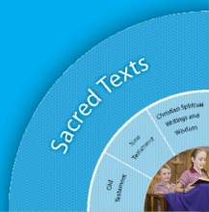 |  | 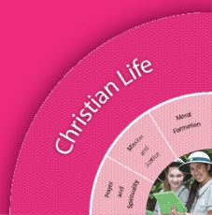  Christian Living  Moral Formation CLMF1, CLMF2  Mission and Justice CLMJ1
Religious Knowledge and Deep Understanding | Skills | Religious Knowledge and Deep Understanding | Skills
- The Gospels tell the good news of Jesus.  - Familiarity with characters, events and messages from some key New Testament stories, including the birth of Jesus (Luke 2:1-7; Matthew 1:18-25), is a means of connecting Scripture and real life. | - Listen and respond to stories of and about Jesus in the Gospels.  - Share feelings and thoughts about the events, characters and messages in some familiar New Testament stories.  - Make links between some familiar New Testament stories and their own experiences by sharing characters, events and messages that may be similar to or different from their own experiences. | Jesus taught key messages about love, compassion and forgiveness, including the parable of the Good Samaritan (Luke 10:29-37). Jesus taught that love of God and others is the greatest commandment. Christians are called to follow the teachings of Jesus. | - Share feelings and thoughts about some of Jesus’ key messages about love, compassion and forgiveness.  - Identify connections between Jesus’ key messages about love, compassion and forgiveness and their personal experience.
Jesus’ wisdom challenged people about the way they were living | Make connections between some of Jesus’ wise statements and how these are expressed in a range of stories. | God’s plan is that people help each other to live safely and happily together. Societal laws are intended to be for the good of all. | - Identify connections between God’s plan for people to live safely and happily, as illustrated by Jesus’ teaching (e.g. The Golden Rule, Matthew 7:12//Luke 6:31), and their personal experience (e.g. at school, home, community).  - Explore their feelings and thoughts about societal laws (e.g. classroom, playground, family, safety) being intended for the good of all, rather than to meet individual wants and needs.

Scriptural Texts
Core texts are prescribed Scriptural texts that need to be taught in depth at each year level.
- The Good Samaritan Luke 10:29-37

Significant Days and Celebrations
- Jesus Day (August 12th)
- Celebration of Learning (Last week of Term 3)

Learning Experiences
Core Content Area One  Focus/Question– How do I be a Good Samaritan today?  ….walking in the footsteps of Jesus…. |  | Resources  Teacher Background  Mandated Scriptural Texts
Tuning In | - Read children the story from the Bible.  - Read children the story in the form of a picture book.  - Let children view a youtube clip of the story. | Children’s Bible  Big book of the Good Samaritan
Finding Out | - Discuss the story with children. Teacher retells the story and highlights the important characters and events in the story.  - In small groups children draw/paint their favourite part or character of the story and explain to the Teacher aide why that was their favourite character and that was recorded on the back of the child’s drawing and displayed in the classroom  - In small groups, have children role play sections/parts of the story.
Sorting Out | - Using picture cards have children sequence the story from beginning to end.  - As a class, discuss what children could do to be like the Good Samaritan in a classroom context.  - Introduce the ‘Good Samaritan’ cards to children and how they will be placed on the road/map to Jericho in the classroom. ( A good Samaritan card is given to a child when they are ‘caught out ‘ helping their friends or peers). | Good Samaritan Cards
Communicating | - Using photobabble, have children record why they received a ‘Good Samaritan’ card.  - Using ipads, record children retelling the story of the ‘Good Samaritan’ using their sequencing cards for prompting.
Reflecting and Evaluating  - So what have I learnt?  - If I know this, how can I connect it with my world? | - Using feeling cards, get children to share how the story of the ‘Good Samaritan’ made them feel and which part of the story they liked the best and least, etc.  - Children share new learnings and work with families.
 | - Evaluation Assessment Tasks for Learning/of Learning, Evidence
 | - Evaluation of Teaching: What I would have done differently…What worked really well

http://www.rec.bne.catholic.edu.au/Pages/Religious-Education.aspx#

