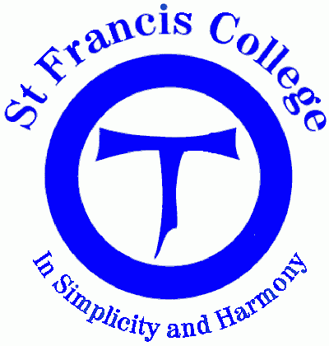
St Francis College Crestmead YR 7 Religious Education 2014 Student Profile

Year 7 Achievement Standard
By the end of Year 7, students recognise that sacred texts reflect the audience, purpose and context of their human authors. They explain how sacred texts influence the life of believers. They explain the significance of Church teaching and basic principles of Christian morality for the way believers live out their faith, personally and communally.

Students investigate the beginnings of the Christian faith (c.6 BCE – c. 650 CE) and explain the role of key people and events in its development. They explain some ways in which Christianity shares common beginnings of faith with the other monotheistic religions (Judaism and Islam). They describe some ways in which the faith of believers is expressed, professed and lived out in different communities, past and present. They suggest reasons for change and continuity in the life of Church and religious communities over time and place. They explain the significance of prayer, ritual, sacraments and sacred texts for the faith journey of believers, personally and communally. They participate respectfully in a variety of prayer experiences, including formal prayers such as the Hail Mary and Our Father; meditative prayer including Lectio Divina and Ignatian Meditation; and meditative prayer practices including silence and stillness, and praying with icons and images.
Student Name:
RELIGION | Term 1  St Francis and where it all began |  |  | Term 2  Power of words |  |  | ONE | Term 3  Doing good |  |  |  | Term 4  Sacraments and sacramentality
Instruments  Criteria |  |  |  |  |  |  | SEMESTER ONE |  |  |  |  |  | FINAL  EXIT
Knowledge & Understanding
Processing Skills
Communication skills
Level of Achievement

