St Francis College  NAME: ....................................  TEACHER: Miss Litzow, Miss Andzue  SUBJECT: Religion  TERM 3  CONDITIONS  Time allowed: 2 weeks  Length: 2 pages  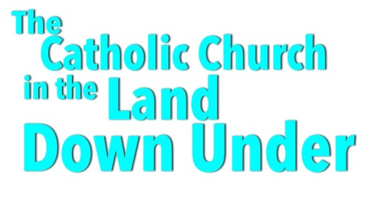 | Great Australian Catholics
 | In class we have been learning about the Catholic Church and its associated organisations in Australia. We have also been learning about Jesus and his mission and how it is the foundation to the Church’s spiritual and corporal works of mercy.

YOUR TASK:

Your task is to use the website ‘Twenty-five of the Best!’ to research an Australian Catholic, past or present, whose faith has been a significant part of their lives.
You must investigate and record information based on the questions below and display the information as a brochure.
- When was this person born? What was happening in Australia at this time?
- What are the major achievements and actions of this person?
- Did this person write or speak about their faith? What did they have to say?
- Identify and explain the spiritual or corporal work/s of mercy this person lived out.
- Using the scriptural text Matthew 25:31-46, highlight the passage that relates to the identified work of mercy?
- How did/does this person share their faith with others?
- What outcomes resulted from this person’s efforts?
- What are four or five keywords you would use to describe this person’s spirituality?
- In what ways would you like to be like him or her?

*A planning sheet has been provided

