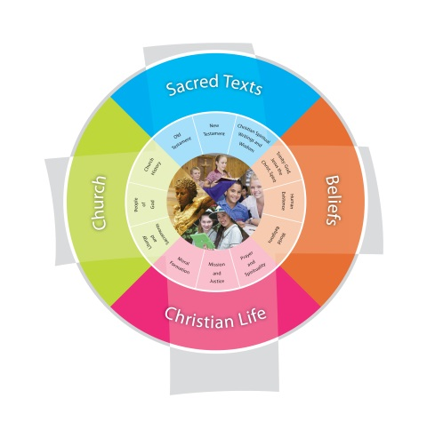
Doing Good Year 7 2014
St Francis College Duration Term 3
Fertile Question
What’s so good about doing good?
VISION for Religious Education
The Vision for Religious Education gives voice to what each school hopes for their students in terms of their religious literacy and faith formation.
The schools and colleges of the Archdiocese of Brisbane aspire to educate and form students who are challenged to live the gospel of Jesus Christ and who are literate in the Catholic and broader Christian tradition so that they might participate critically and authentically in faith contexts and wider society.

Religious Life of the School | General Capabilities | Cross-Curricular Priorities
Religious Identity and Culture  - Ethos and charism (ICE) Remembering St Clare and St Max Kolbe  Evangelisation and Faith Formation  - Living the Gospel (EFG)  Identifying and using scriptural texts to promote and support the Christian values of the school  Prayer and Worship  - Christian prayer (PWP)  Providing a variety of prayer experiences including Ignatian Examen and Lectio Divina | - Literacy  - Numeracy  - Critical and creative thinking  - Personal and social capability  - Ethical understanding
Year Level Description
The Religion Curriculum involves four strands: Sacred Texts, Beliefs, Church and Christian Life. These strands are interrelated and should be taught in an integrated way; and in ways that are appropriate to specific local contexts. In Year 7, students learn about the beliefs, values and practices of Christian communities, past and present, including early Church communities (c.6 BCE - c. 650CE), communities of religious men and women and Australian Catholic Church communities. They explore cultural and historical influences on these communities and change and continuity over time. They learn about the common beginnings of faith shared by the monotheistic religions (Christianity, Judaism and Islam) through the stories of patriarchs, Moses and the prophets. They explore ways in which communities of believers, past and present, express their understanding of God and God’s relationship with human persons. In particular, they develop their understanding of the Apostles Creed, Nicene Creed and the Decalogue.
Students explore contextual information about sacred texts, using a range of Biblical tools, to gain a deeper awareness of these texts and how they influence communities of believers. They examine Church teaching and basic principles of Christian morality that influence the way Christians live out their faith, individually and communally.

Students examine ways in which believers nurture their spiritual life through prayer, ritual, the sacraments and sacred texts. They develop their understanding of prayer in the Christian tradition through an exploration of Lectio Divina and Ignatian Meditation. They investigate the relationship between the Sacraments of the Church, the life and ministry of Jesus, and the faith journey and life experiences of believers

Achievement Standard
By the end of Year 7, students recognise that sacred texts reflect the audience, purpose and context of their human authors. They explain how sacred texts influence the life of believers. They explain the significance of Church teaching and basic principles of Christian morality for the way believers live out their faith, personally and communally.
Students investigate the beginnings of the Christian faith (c.6 BCE – c. 650 CE) and explain the role of key people and events in its development. They explain some ways in which Christianity shares common beginnings of faith with the other monotheistic religions (Judaism and Islam). They describe some ways in which the faith of believers is expressed, professed and lived out in different communities, past and present. They suggest reasons for change and continuity in the life of Church and religious communities over time and place. They explain the significance of prayer, ritual, sacraments and sacred texts for the faith journey of believers, personally and communally. They participate respectfully in a variety of prayer experiences, including formal prayers such as the Hail Mary and Our Father; meditative prayer including Lectio Divina and Ignatian Meditation; and meditative prayer practices including silence and stillness, and praying with icons and images.

Class Context for Learning – Differentiated learning
Class Needs: ASD student; large group of ESL students; indigenous students; low literacy.
Individualised Learning Needs
Catholics/non-Catholics – other faiths – practising/non-practising
II students (Alternative programs)
ASD – ADHD (abstract concepts may need further unpacking – visuals etc…)

Learning Intentions
Learning Intention
By the end these learning experiences, students
- Analyse the Decalogue by examining the worlds of the text
- Investigate how Catholic church teaching influences the way believers live out their faith individually and communally
- Explain the significance of Examen and sacred texts including the Decalogue, golden rule and greatest commandment in the lives of believers.

Success Criteria
Success Criteria
- Make meaning of sacred texts using biblical tools for a contemporary audience
- Explain how believers are influenced by church teaching
- Participate respectfully in an experience of the Examen

Assessment
Assessment: Rewrite the Decalogue so the commandments communicate a way of life faithful to God’s love for a contemporary audience ( world in front of the text)

Content Descriptions
Sacred Texts  Old Testament  New Testament  Christian Spiritual Writings and Wisdom  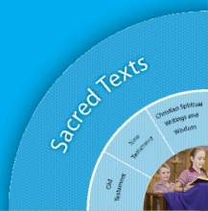 |  | Beliefs -Human Existence BEHE7  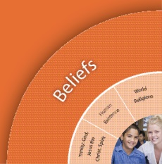
Religious Knowledge and Deep Understanding | Skills | Religious Knowledge and Deep Understanding | Skills
STOT12 Contextual information (literary form, historical and cultural context and human author’s intention) assists the reader to gain deeper awareness of Old Testament texts. The intention of the human author is important in determining the nature of the truth revealed in the text (e.g. historical truth, factual truth, religious truth). | Sequence historical events and periods of Ancient Israel (e.g. prehistory, Patriarchs and Matriarchs, Exodus, Judges, Kings and Prophets, foreign domination) using historical terms and concepts (e.g. BCE, prehistory) and a range of sources (e.g. Bibles, Biblical commentaries).  Identify and explore aspects of the cultural context of Old Testament texts (e.g. festivals and customs, purity laws, religious practices) using a range of Biblical tools (e.g. timelines, Biblical atlases, Biblical dictionaries, annotated Bibles, simple Biblical commentaries, online Bible search engines). | BEHE7 The Decalogue (Exodus 20:1-20) affirms the relationship between God and humankind. It describes a way of life faithful to God’s love. | Illustrate how the Decalogue describes a way of life faithful to God’s love.  Explain the relationship between God and humankind that is revealed in the Decalogue.
Christian Living  Prayer and Spirituality  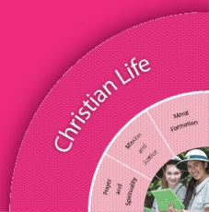 |  | Christian Living  Moral Formation  Mission and Justice
Religious Knowledge and Deep Understanding | Skills | Religious Knowledge and Deep Understanding | Skills
CLPS18 Meditative prayer uses silence and stillness to assist believers to listen and talk to God. Believers use a range of practices (including silence and stillness, and praying with icons and images) for preparing the body and the mind for meditative prayer, and engaging in the ‘work of meditation’. Christian iconography expresses in images the same Gospel message that Scripture communicates by words. Praying with scripture is a form of meditative prayer in the Christian tradition. There are a variety of ways to pray with scripture, including Lectio Divina (Benedictine tradition) and Ignatian Meditation. | Participate respectfully in meditative prayer, including praying with scripture.  Identify and use practices that assist in preparing for and engaging in meditative prayer, including silence and stillness and praying with icons and images. | CLMJ8  Concern for the good of the community is a basic principle of Christian morality. According to Church teaching, personal gifts are meant to be at the service of others and of the common good. The good of the community can be protected and promoted in a variety of ways. | Analyse the Church’s teaching about the common good.  Investigate and present a variety of ways of protecting and promoting the common good.  Explore ways of serving the common good using personal gifts and talents.
 |  | CLMF11  Moral choice involves both discernment and judgement and acting according to that judgment. Doing good and avoiding evil is the basic principle of acting according to a properly formed conscience. Sin is a personal act with personal accountability. Sin also has a social dimension as each individual’s sin in some way affects others. | Examine sources (e.g. Church teaching, Word of God, contemporary media, human wisdom) to explain the basic principle of acting according to a properly formed conscience.  Explain the relationship between personal accountability and the social dimension of sin.

Scriptural Texts
Core texts are prescribed Scriptural texts that need to be taught in depth at each year level.
Decalogue Exodus 20: 1-20
Supplementary texts are other possible Scripture texts that could be used to support the teaching of particular concepts.
Golden Rule Matthew 7:12, Greatest commandment John 13:34-35

Significant Days and Celebrations
St Clare, St Maximilian Kolbe, feast day of the Assumption

Learning Experiences
Core Content Area One  Focus/Question–  How do we know how to be good? |  | Resources  Teacher Background  Mandated Scriptural Texts  Connections to other curriculum areas
Tuning In  - What is the topic?  - Why should we study this topic?  - Frame manageable questions.  - What do I already know about this topic? I think I know x,y,z.  - How is this relevant to me? | - KWHL chart. Brainstorm with whole class.  - What does being/doing good mean? What is good?  - What are some reasons we might want to be good? Y-chart  - Trading cards: How do we learn how to be good? Who teaches us to be good? What guides us to be good? | KWHL chart on p 174/5 of ITC Primary Teacher’s Companion 2014
Finding Out  - Identify possible sources of information  - Identify skills necessary for the investigation.  - How did it happen? Who was there and what were the facts? | - Do you know anything in history that tells us/guides us in being good?  - RAS alert YouTube clip of a biblical story. See link opposite. Use the first video. The second is an extra.  - Reading to Learn activity to make meaning Exodus 20:1-20 (Full RTL cycle) | Exodus 20:1-20  Geography  Teacher background http://www.rec.bne.catholic.edu.au/Pages/Theological-Background-Details.aspx?tbid=69  RAS alert videos  http://youtu.be/nFHlZ_zgx-E?list=PLITIvf9e1aLNoZhARfc_6iMyJNROIOT1H  http://youtu.be/zyBuJm4aNfA?list=PLITIvf9e1aLNoZhARfc_6iMyJNROIOT1H  RAS alert activity page 194/5 of ITC Primary Teachers Companion 2014
Sorting Out  - What do we want to find out?  - How can we do this best?  - How will we gather the information?  - Does what I knew before still apply?  - Does my first idea still make sense? | - Other texts: Golden rule, Poster of golden rule, Greatest commandment.  - Deconstruct these texts and make meaning for today. How do texts like this help believers to make good choices? What else helps us make good choices? (Conscience, parents, peers, rules) Use Attribute Listing Organiser to analyse these questions.  - Church teaching about the common good. Investigate the three essential elements of the common good. Respect for the person, the social wellbeing and development of the group, ensuring peace, identifying examples from school culture, policies and practices that protect the common good. Use Image Associated Ideas activity combined with a silent card shuffle.  - Role plays of good choice/bad choice scenarios.  - Contextualise the role of prayer for believers.  - Have an experience of Examen | Attribute Listing Organiser p 126/7 of ITC Primary Teacher’s Companion 2014  Elaborations page 137  Image Associated Ideas activity on page 170/1 of ITC Primary Teacher’s Companion 2014
Communicating  - Extend and challenge students’ understandings | Assessment: Rewrite the Decalogue so the commandments communicate a way of life faithful to God’s love for a contemporary audience ( world in front of the text)
Reflecting and Evaluating  - So what have I learnt?  - If I know this, how can I connect it with my world? | - KWHL – complete individual KWHL charts from beginning of unit as feedback.  - Review Lectio Divina from Term 2 and have an experience of Lectio using the Decalogue or golden rule by way of reflection.  Students complete the evaluation of student learning worksheet and compare with last term to assess their learning growth for the term. | Evaluation of Student Learning Worksheet

