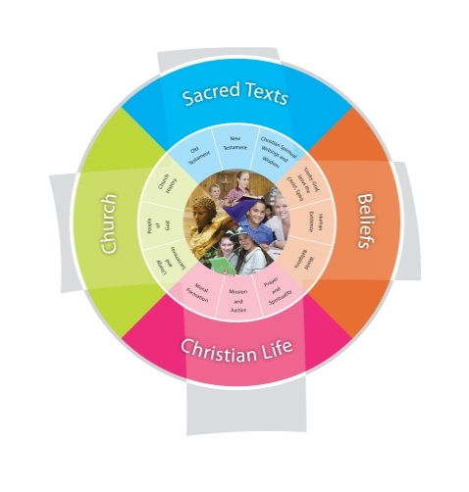
Year 2 Term Three: Forgiveness
School: St Francis Duration 10 weeks
Fertile Question
How can I continue to build a world of love?
VISION for Religious Education
The Vision for Religious Education gives voice to what each school hopes for their students in terms of their religious literacy and faith formation.
The schools and colleges of the Archdiocese of Brisbane aspire to educate and form students who are challenged to live the gospel of Jesus Christ and who are literate in the Catholic and broader Christian tradition so that they might participate critically and authentically in faith contexts and wider society.

Religious Life of the School | General Capabilities | Cross-Curricular Priorities
Evangelisation and Faith Formation  - Living the Gospel (EFG)  - EFG1.4 Creating a culture of hope optimism joy and inclusion that reflects the life of Jesus Christ through routines and practices  - EFG2.1 Develop a culture of forgiveness and reconciliation  - EFG3.3 Introducing elements of Christian joy and hope into the celebrations of school life  Prayer and Worship  - Christian prayer (PWP1.4 Creating a class prayer book of sorry prayers)  - PWP1.1 Teaching a variety of Christian prayers  - PWR2.5 planning prayerful reflective practices as part of learning and teaching eg celebration of learning. | - Literacy  - Personal and social capability  - Ethical understanding  - Intercultural understanding. | - Aboriginal and Torres Strait Islander histories, cultures and spiritualities
Year Level Description
The Religion Curriculum P-12 involves four strands: Sacred Texts, Beliefs, Church and Christian Life. These strands are interrelated and are taught in an integrated way, and in ways that are appropriate to specific local contexts.

In Year 2, students learn about aspects of God’s nature and God’s relationship with people, as they engage with a variety of New Testament texts depicting the teachings and actions of Jesus and Old Testament texts that describe God’s relationship with the Jewish people. They explore contextual information about the first century Mediterranean world, to better appreciate the life and times of Jesus. They learn about Jesus’ mission and ministry and explore ways in which Jesus’ teachings and actions continue to guide the life of the Church community today. They explore, recognise and appreciate the history of a parish community as it is revealed in many ways.

Students learn about the sacredness of all creation, especially human life; the call to be co-creators and stewards of God’s creation; and the responsibility to pursue peace and justice out of respect for human life and all creation. They develop their understanding of the loving relationship God unconditionally offers to people; and their understanding of sin, as evident in the free choices that harm the individual and their loving relationships with God, with others and with all creation. They explore ways in which believers seek to heal these relationships through reconciliation and prayer. They investigate ways in which believers celebrate reconciliation with God and with others in the Sacrament of Penance.

Students examine ways in which prayer and the wisdom of the saints help believers to nurture their loving relationships with God, with others and with all creation. They develop their understanding of prayer in the Christian tradition through an exploration of prayer for forgiveness (acts of contrition and Penitential Act) and meditative prayer.
Achievement Standard
By the end of Year 2, students analyse some teachings and actions of Jesus depicted in New Testament texts that reveal aspects of God’s nature. They discuss their ideas about God’s relationship with the Jewish people as described in some Old Testament stories. Students pose questions about the life and times of Jesus and use sources provided to answer these questions. They make connections between Jesus’ teachings and actions and the way members of the Church community live today.
Students recognise the sacredness of God and all creation, especially human life. They identify ways in which human beings respond to the call to be co-creators and stewards of God’s creation. Drawing on their own experiences, they suggest ways to pursue peace and justice out of respect for human life and all creation. They recognise choices that harm an individual and their loving relationships with God, with others and with all creation. They explain ways in which believers seek to heal these relationships through reconciliation and how they celebrate reconciliation in the Sacrament of Penance. They recognise that prayer and the wisdom of the saints help the believer to nurture their relationship with God, with others and with all creation. They participate with respect in a variety of personal and communal prayer experiences, including meditative prayer and prayers for forgiveness.

Class Context for Learning – Differentiated learning
Variety of Religions/faiths. Samoan families who regular practise their faith. Islamic families. Catholics and non-Catholics.
One verified child with autism and globally delayed. 16 EALD children and others with behavioural needs
Children on individual learning plans have their work adapted accordingly. e works with the class. Dot writing used for those with delayed fine motor development. Sometimes scribe for children to record ideas who have difficulty writing independently

Learning Intentions
Learning Intention
By the end these learning experiences, students
- explore ideas about God's love and God's relationship with God’s people as revealed in stories from the NewTestament.
- identify and describe terms such as loving , just, welcoming and forgiving. They identify teachings and actions of Jesus through New Testament stories (Luke 15:11-31, Luke 19:1-10) that reveal aspects of God's nature.
- identify and describe ways in which believers seek to heal broken relationships through reconciliation, forgiveness and prayer.
- make connections between sin (missing the target) and the consequences of their choices.
- investigate how the Sacrament of Penance (reconciliation) can help to build a world of love.

Success Criteria
Students discuss ideas about God’s relationship with God’s people as described in New Testament stories
Students provide evidence of how New Testament texts (Luke 15:11-31, Luke 19:1-10) reveal aspects of God’s nature.
Students explain how believers seek healing through reconciliation and how they celebrate reconciliation through the Sacrament of Penance

Assessment
Students in small learning teams prepare a retelling of either The Prodigal Son or Zacchaeus using drama, puppets or the visual arts. They present their retelling to the class. Students discuss as a class what the stories tell about God.
Students complete statements about God using words from the following list: father, welcoming, sorry, forgiving others, love.
For example: "Jesus taught that God is like a loving father."
"Forgiving others and saying sorry helps to create a world of love." They post their statements as posties on a class collaborative space such as an online wall in Life or using Padlet.
Students reflect each day where and when they have witnessed themselves or others acting to build a community of love.
Students contribute to a class mural by creating a visual response that shows examples of actions of how they can be more loving, welcoming and forgiving.
Students role play or use puppets to practice admitting wrong, saying sorry, forgiving, being forgiven and making up.
Students complete a Y chart about the Sacrament of Penance (Reconciliation).

Content Descriptions
Sacred Texts  Old Testament STOT5  New Testament STNT5  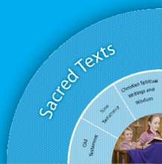 |  | Beliefs  Trinity BETR4  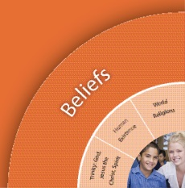
Religious Knowledge and Deep Understanding | Skills | Religious Knowledge and Deep Understanding | Skills
OLD TESTAMENT  Christians venerate the Bible as a sacred book in many ways, including proclamation in prayer celebrations and meditative reflection in personal prayer.  Familiarity with characters, events and messages from some key Old Testament stories, | Use and display the Bible respectfully.  Listen with respect as Scripture is proclaimed in prayerful settings  Make links between some familiar Old Testament stories and their own experiences by sharing characters, events and messages that may be similar to or different from their own experiences. | Jesus lived a truly human life. His mission and ministry was to preach and bring about the Kingdom of God, including through his teaching, healing and forgiving. | Identify the purpose and nature of Jesus’ mission and ministry as depicted in some Gospel stories.  Describe the effect of Jesus’ mission and ministry on the lives of key characters in some Gospel stories
NEW TESTAMENT  The Gospels tell the good news of Jesus. | Listen and respond to stories of and about Jesus in the Gospels
Church  Liturgy and Sacraments CHLS3  People of God CHPG3  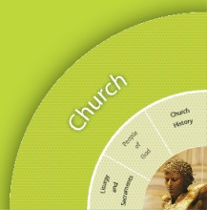 |  | Christian Living  Moral Formation CLMF5  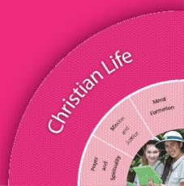  Prayer and Spirituality CLPS6
Religious Knowledge and Deep Understanding | Skills | Religious Knowledge and Deep Understanding | Skills
The Church has important ways of praying together through celebrations and rituals, marking special times in the life of believers | Identify celebrations and rituals that mark special times in the life of the Church community | Jesus taught key messages about love, compassion and forgiveness, including the parable of the Good Samaritan (Luke 10:29-37). Jesus taught that love of God and others is the greatest commandment. Christians are called to follow the teachings of Jesus. | Share feelings and thoughts about some of Jesus’ key messages about love, compassion and forgiveness.  Identify connections between Jesus’ key messages about love, compassion and forgiveness and their personal experience.
 | Make connections between Church rituals and special times in the lives of believers | Meditative prayer uses silence and stillness to assist believers to listen and talk to God. There is a range of practices (including being silent and still, and lighting a candle) that helps believers prepare the body and the mind for meditative prayer and engage in the ‘work of meditation’. | Participate respectfully in meditative prayer.  Identify and use practices that assist them to prepare for and engage in meditative prayer.

Mandated Scripture and Prayer
Core texts are prescribed Scriptural texts that need to be taught in depth at each year level.
Zacchaeus Luke 19:1-10
The Lost Son/The Forgiving father Luke 15:11-31
Core Prayer
Create Sorry Prayers, Penitential Rite, Act of Contrition

Significant Days and Celebrations
Celebration of learning Week 10
Peace march in Week 5
Catholic Education Week 3

Learning Experiences
Core Content Area One – OLD TESTAMENT  Focus/Question–  How can I continue to build a world of love? |  | Resources  Teacher Background  Mandated Scriptural Texts
Tuning In  - What is the topic?  - Why should we study this topic?  - Frame manageable questions.  - What do I already know about this topic? I think I know x,y,z.  - How is this relevant to me? | Explore the fertile question How can I continue to build a world of love?  Students listen to or view a story such as God's Dream by Desmond Tutu and Douglas Carlton Abrams. Students share ideas from the story about God's dream for the world.  Students imagine that God's dream for the world is a world of love and describe one or two things that definitely would be happening and one or two things that definitely wouldn't be happening in that world. They include examples from the classroom. Students demonstrate their ideas either by role playing or by speaking.  Note to teachers: Record students initial ideas about what a world of love is like to compare to ideas at the end of the Unit  Students draw their world of love in their religion book and describe what their world of love looks like  A class mural is used throughout this unit to record their reflections on how they build a world of love | You tube clip of  Desmond Tutu’s book Visuals assist EALD students with the story  Teacher to scribe for children with individual needs
Finding Out  - Identify possible sources of information  - Identify skills necessary for the investigation.  - How did it happen? Who was there and what were the facts? | Investigate the world of love in the Bible  Students are introduced to the Bible as a sacred text, a library of books that tell readers about God's love for the world. They listen as the teacher explains that the Jewish people, the Ancient Israelites (like Noah) whose stories appear in the Old Testament of the Bible are stories that describe God's special relationship with them. The teacher explains that these were the stories that Jesus would have known because he was also a Jew. Students recall some old Testament stories that they have heard and share with the class. | Retrieval Chart  Teacher copy A3
Sorting Out | Students listen to or view the story of the call of Abraham and Sarah. Students complete a class retrieval chart to analyse the story and determine what it says about the nature of God and God's relationship with the Jewish people. Using the emoticons on the retrieval chart, students discuss and identify the emotions of Abraham and Sarah in the story. Note to Teacher: Students may similarly explore the story of Joseph's forgiveness of his brothers Genesis 50:15-21.
Reflecting and Evaluating  - So what have I learnt?  - If I know this, how can I connect it with my world? | Reflect on God's love for the world  Students listen to the song Good Things by Maria Millward and Damian Halloran on the Great Stories and Songs CD and identify some good things that came to Abraham and Sarah in the Genesis story. They make a written or artistic representation of some good things that have happened in their life. Students share their representation as part of a class prayer of thanksgiving for the good things that they have received. | 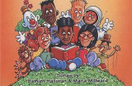  The song Good Things by Maria Millward and Damian Halloran on the Great Stories and Songs CD

Core Content Area Two – NEW TESTAMENT & what Jesus reveals  Focus/Question–  How can I continue to build a world of love? |  | Resources  Teacher Background
Tuning In | Identify, discuss and demonstrate a range of emotions and how they can be recognised  Students identify different emotions as they read and watch a story such as John Brown's Rose meets Mr Wintergarden. They discuss the different emotions in the story. Students share and discuss times when they have felt these emotions. They demonstrate facial expressions to illustrate the emotions which are then photographed or drawn to create a visual classroom display.  Students connect facial expressions with feelings and discuss times when they couldn't tell how a person was feeling because they didn't show the emotion on their face.  Students use a Y Chart strategy in small groups to share understandings about what the following words look like, sound like and feel like: loving, just, welcoming, forgiving and sorry. They work together to create class definitions for each word which are then added to a shared vocabulary space.  Students create masks to illustrate the emotions discussed during this tuning in phase using paper bags, paper plates or other recyclable materials. They use the mask in freeze frames to illustrate a feeling response to teacher created scenarios.  Note to teacher: Freeze frames by students could be photographed and added to a visual wall display. Masks can be kept to assist students to explore emotional responses of characters in New Testament stories. | 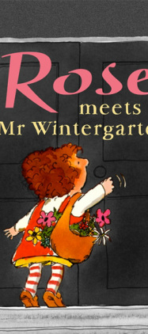
Finding Out | Students listen as the teacher reminds them about the Bible as sacred text and how just as the Old Testament has stories about God and God's relationship with the Jewish people, The New Testament shows God's love for the world through stories about Jesus and his followers. Students share what they know about the Bible and New Testament stories. They discuss stories they know about Jesus and what he taught about love.  Students listen to or view a story that reveals God's unconditional love, the story of the Prodigal son Luke 15:11-32. They discuss as a class the characters in the story and the relationships between them.  Students form groups of three and each completes a character map for one of the main characters ( father, older son or younger son) whilst viewing a lego animation of the Prodigal son story. They record what their character might be thinking or feeling during different parts of the story:  At the beginning when the young son takes his father's money and goes away,  In the middle when the son is away spending all the money,  Towards the end when the money is gone  At the end when the son returns home  and the father throws the younger son a party.  Students share their maps with the other members of their group.  Students discuss as a class, which characters showed unconditional love, welcoming, forgiveness and being sorry. They brainstorm what they think the writer of this story was trying to say about God and about love.  Note to teachers: Keep the student character maps for reference in Core Content Area Three God's love is unconditional. | Lego animation  (Note: very popular with the students esp the boys although it did influence the way they drew the characters of the story)
Sorting Out | Explore further teachings of Jesus about a world of love  Students view or listen to the New Testament story of Zacchaeus Luke 19: 1-10 . Students use a Character map strategy to describe how Zacchaeus felt before he met Jesus and after he met Jesus. Students discuss how Jesus was forgiving of Zacchaeus and how this helped Zacchaeus to become a changed person.
Communicating | Identify some teachings and actions of Jesus that reveal aspects of God’s nature  Students in small learning teams prepare a retelling The Prodigal son and Zacchaeus using drama, puppets or the visual arts. They present their retelling to the class. Students discuss as a class what the stories tell about God.  Students complete statements about God using words from the following list: father, welcoming, sorry, forgiving others, love.  For example: "Jesus taught that God is like a loving father."  "Forgiving others and saying sorry helps to create a world of love." They post their statements as posties on a class collaborative space such as an online wall in Life or using Padlet. | Assessment Task – retelling of the Prodigal son  Adjustments for learning needs. Prompts given to remind what happened in the story and how the character might have.  A scribe was supplied to create dot writing of the children’s ideas. Student completes by tracing over.
Reflecting and Evaluating | Reflect on learnings from the stories  Students reflect each day where and when they have witnessed themselves or others acting to build a community of love.  Students contribute to a class mural by creating a visual response that shows examples of actions of how they can be more loving, welcoming and forgiving. | 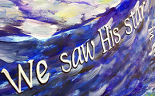

Core Content Area Three  Focus/Question– How can I continue to build a world of love? |  | Resources  Teacher Background
Tuning In | Explore the nature of God's love as being unconditional  Students listen to or view children's literature such as Koala Lou by Mem Fox, . They reflect on the story and discuss as a class examples of when they have felt loved. They could make a digital response to the story in a collaborative space such as Life or Primary Pad by completing a sentence I feel loved when...Students responses are collated to create a class Wordle , Taxgedo or collage.  Students share stories of times when they felt less loved (e.g. when they made wrong choices). They explore the nature of God's love as being unconditional and recall the story of The Prodigal Son by reviewing their character map created earlier in this unit.
Finding Out | Identify evidence from Bible stories about healing hurt relationships  Students investigate the idea of unconditional love by re-examining the parable and the characters of the Prodigal Son. They complete a retrieval chart to identify the steps that were taken to heal the hurt relationship between the father and son.  Students are introduced to the steps to reconciliation/penance  Admit wrong, say sorry, seek forgiveness, penance.  Students complete worksheets. They draw pictures to represent an example of when they said sorry and were forgiven.  Students are reminded of prayers about forgiveness including the Our Father. They are introduced to the Act of contrition as a way of praying for forgiveness. They practise the prayer before they used it. | Work sheet to introduce the steps to forgiveness.
Reflecting and Evaluating | Reflect on steps for healing relationships  Students discuss the connection between being sorry and being forgiven by reflecting on what might have happened to the relationship between the father and son if the son had never gone home and said he was sorry or if the father had not forgiven him.  Students view the short clip about the importance of forgiveness. They listen as the teacher explains that healing relationships, being forgiven and forgiving others is an important way to build a loving world.  Students write sorry prayers and share them in a class ritual as a way to build God’s love in the classroom.  Students re- enact the Prodigal son and said their sorry prayers in the end of term liturgy/Celebration of Learning. The audience is made up of family and friends.

