Religious Education in the Year 7 class for Parents
Term One | Term Two | Term Three | Term Four
Where it all began  Fertile Question: Who was St Francis and who  are we?  Students create a Classroom covenant and  an introduction to St Francis as our patron Saint and the founder of a religious community. They also look at the origins of the Christian church and other faith traditions. | The Power of Words  Fertile Question: How can something written so long ago matter today?  Students investigate the nature of truth and the Creeds and are introduced to the Christian Meditative practice of praying with Scripture – Lectio Divina.  Students prepare for and participate in a class Mass at the local Parish Church.  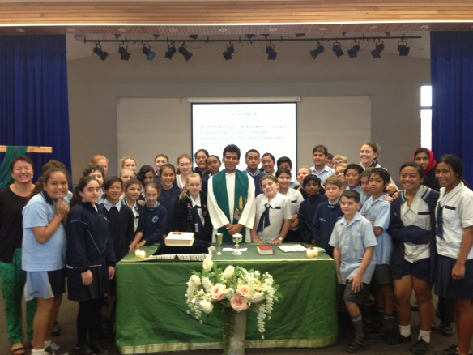 | Doing good  Fertile question: What’s so good about being good?  Students study the Decalogue and what guides us to be good. They learn about Ignatian meditation. | Sacraments and Sacramentality  Fertile Question: How do wecelebrate our most significant moments?  Students investigate the way that Sacraments support the journey of faith. They participate in meditative prayer.

